
A Monthly Publication of Our Savior’s Lutheran Church, Hutchinson, MN

February 2026
CrossTalk Newsletter

The Mission of Our Savior's Lutheran Church and School is ‘connecting families in Christ’ by proclaiming the forgiveness of sin in the Gospel and the Sacraments.

Grace, mercy, and peace to you this February, a month of consideration and love. Isn’t it a fabulous thing that life here on Earth is created to be in community with one another? Dare I say that even life in heaven was first designed as life together. Is that not the reason God created us to begin with that we would have life with Him. And certainly, Adam was found to be sad, despite being in paradise, because it is not good for man to be alone. Such is the nature of being created in a relationship. Even a child is in an immediate and dependent relationship mother to child. Such a beautiful balance of how we need one another day to day.

These meditative thoughts are my way of saying “Happy Valentine's Day!” What could be considered a romantic focus, actually touches on all expressions of love. Did we not give Valentine's candy hearts to our friends in third grade? Did we not share the expression of happiness to our mothers and fathers, grandmas and grandpas on February 14th? We learned early on that Jesus wants us to show love to everyone, just as it is this Christian thing to do, because He first loved us. And Martin Luther would expound on this truth that it is our job, our vocation to show love to family and neighbors alike. Whether we help with chores or show a simple kindness in sharing the bounty of our food, it is the Christ-like thing to do.

May the Lord bless us in this month of February to bring His love to every relationship we find ourselves in. It is for this purpose we were created. It is for this reason that God has woven our lives together in church, work, and community. We need one another, and we are truly blessed to have one another. I am a better person for the family I have. The Church is a better place for having you in it! And the community is a better town when we support peace and unity, no matter who comes to visit. So may we be filled with an extra measure of God’s love to share the abundance as a benefit to all. I believe this is what God means by life together.

God’s peace be yours,


Pastor Gadbaw



From Our Health Ministry
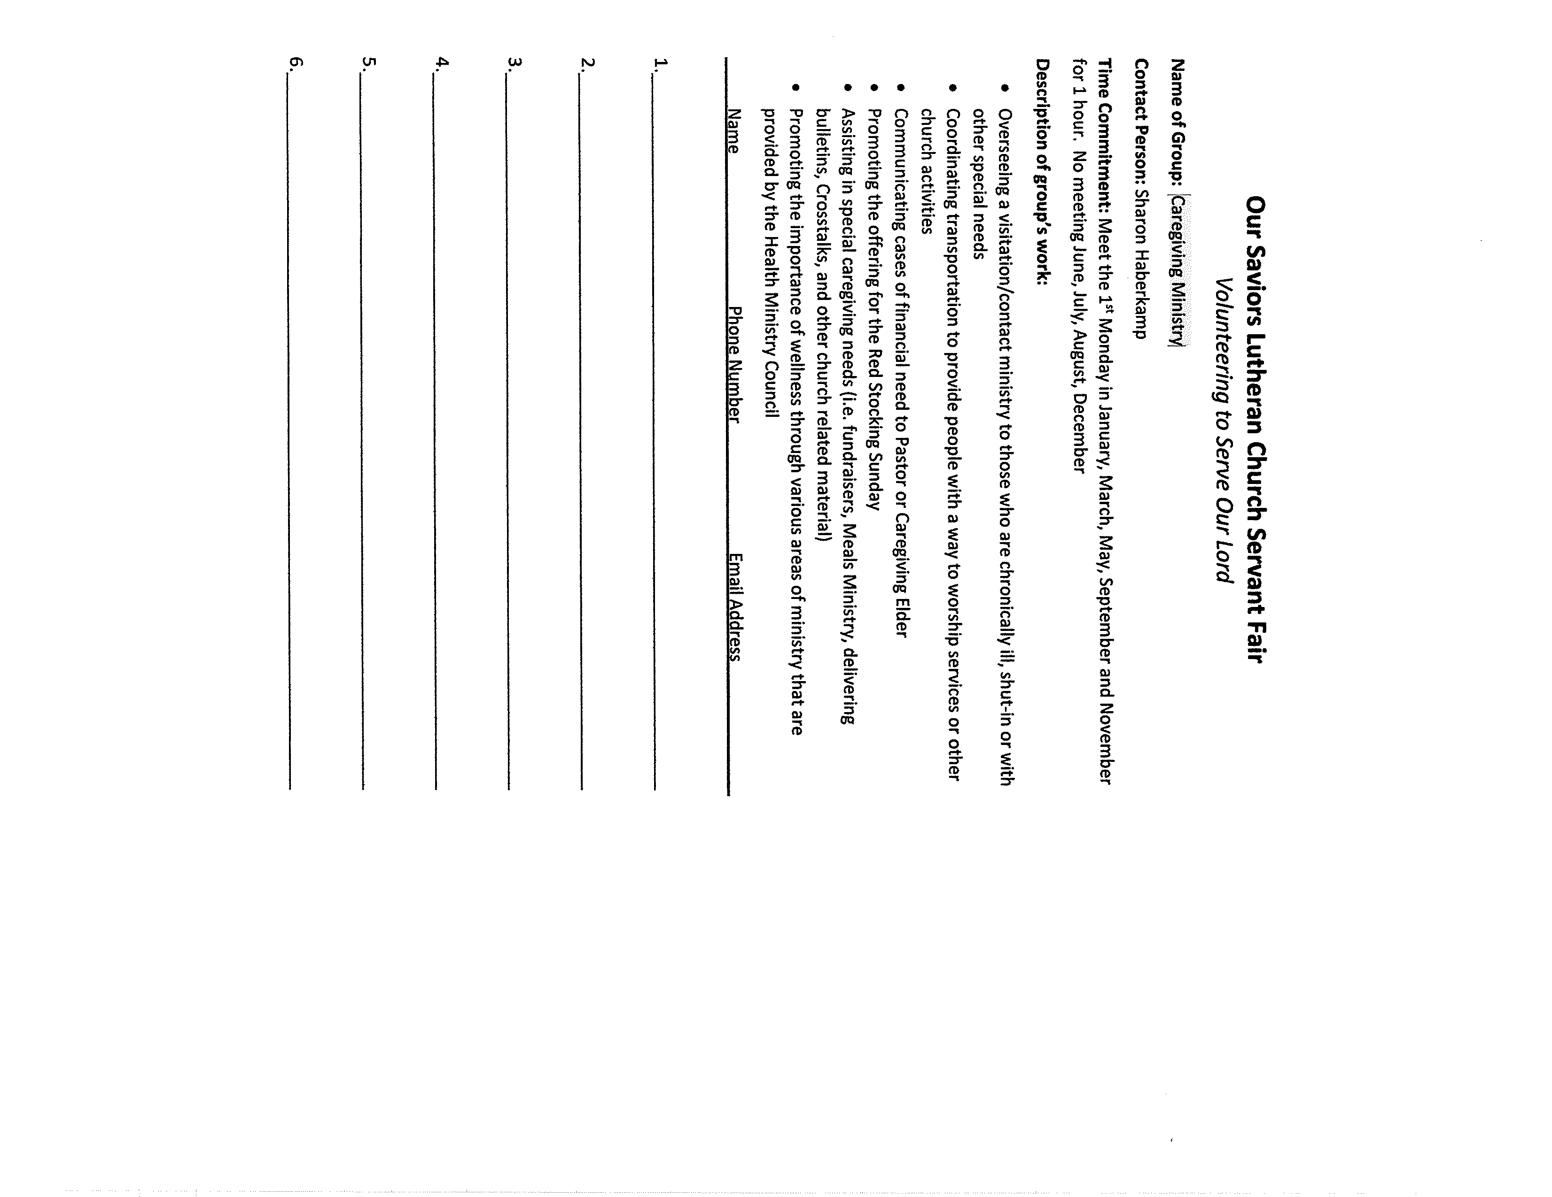
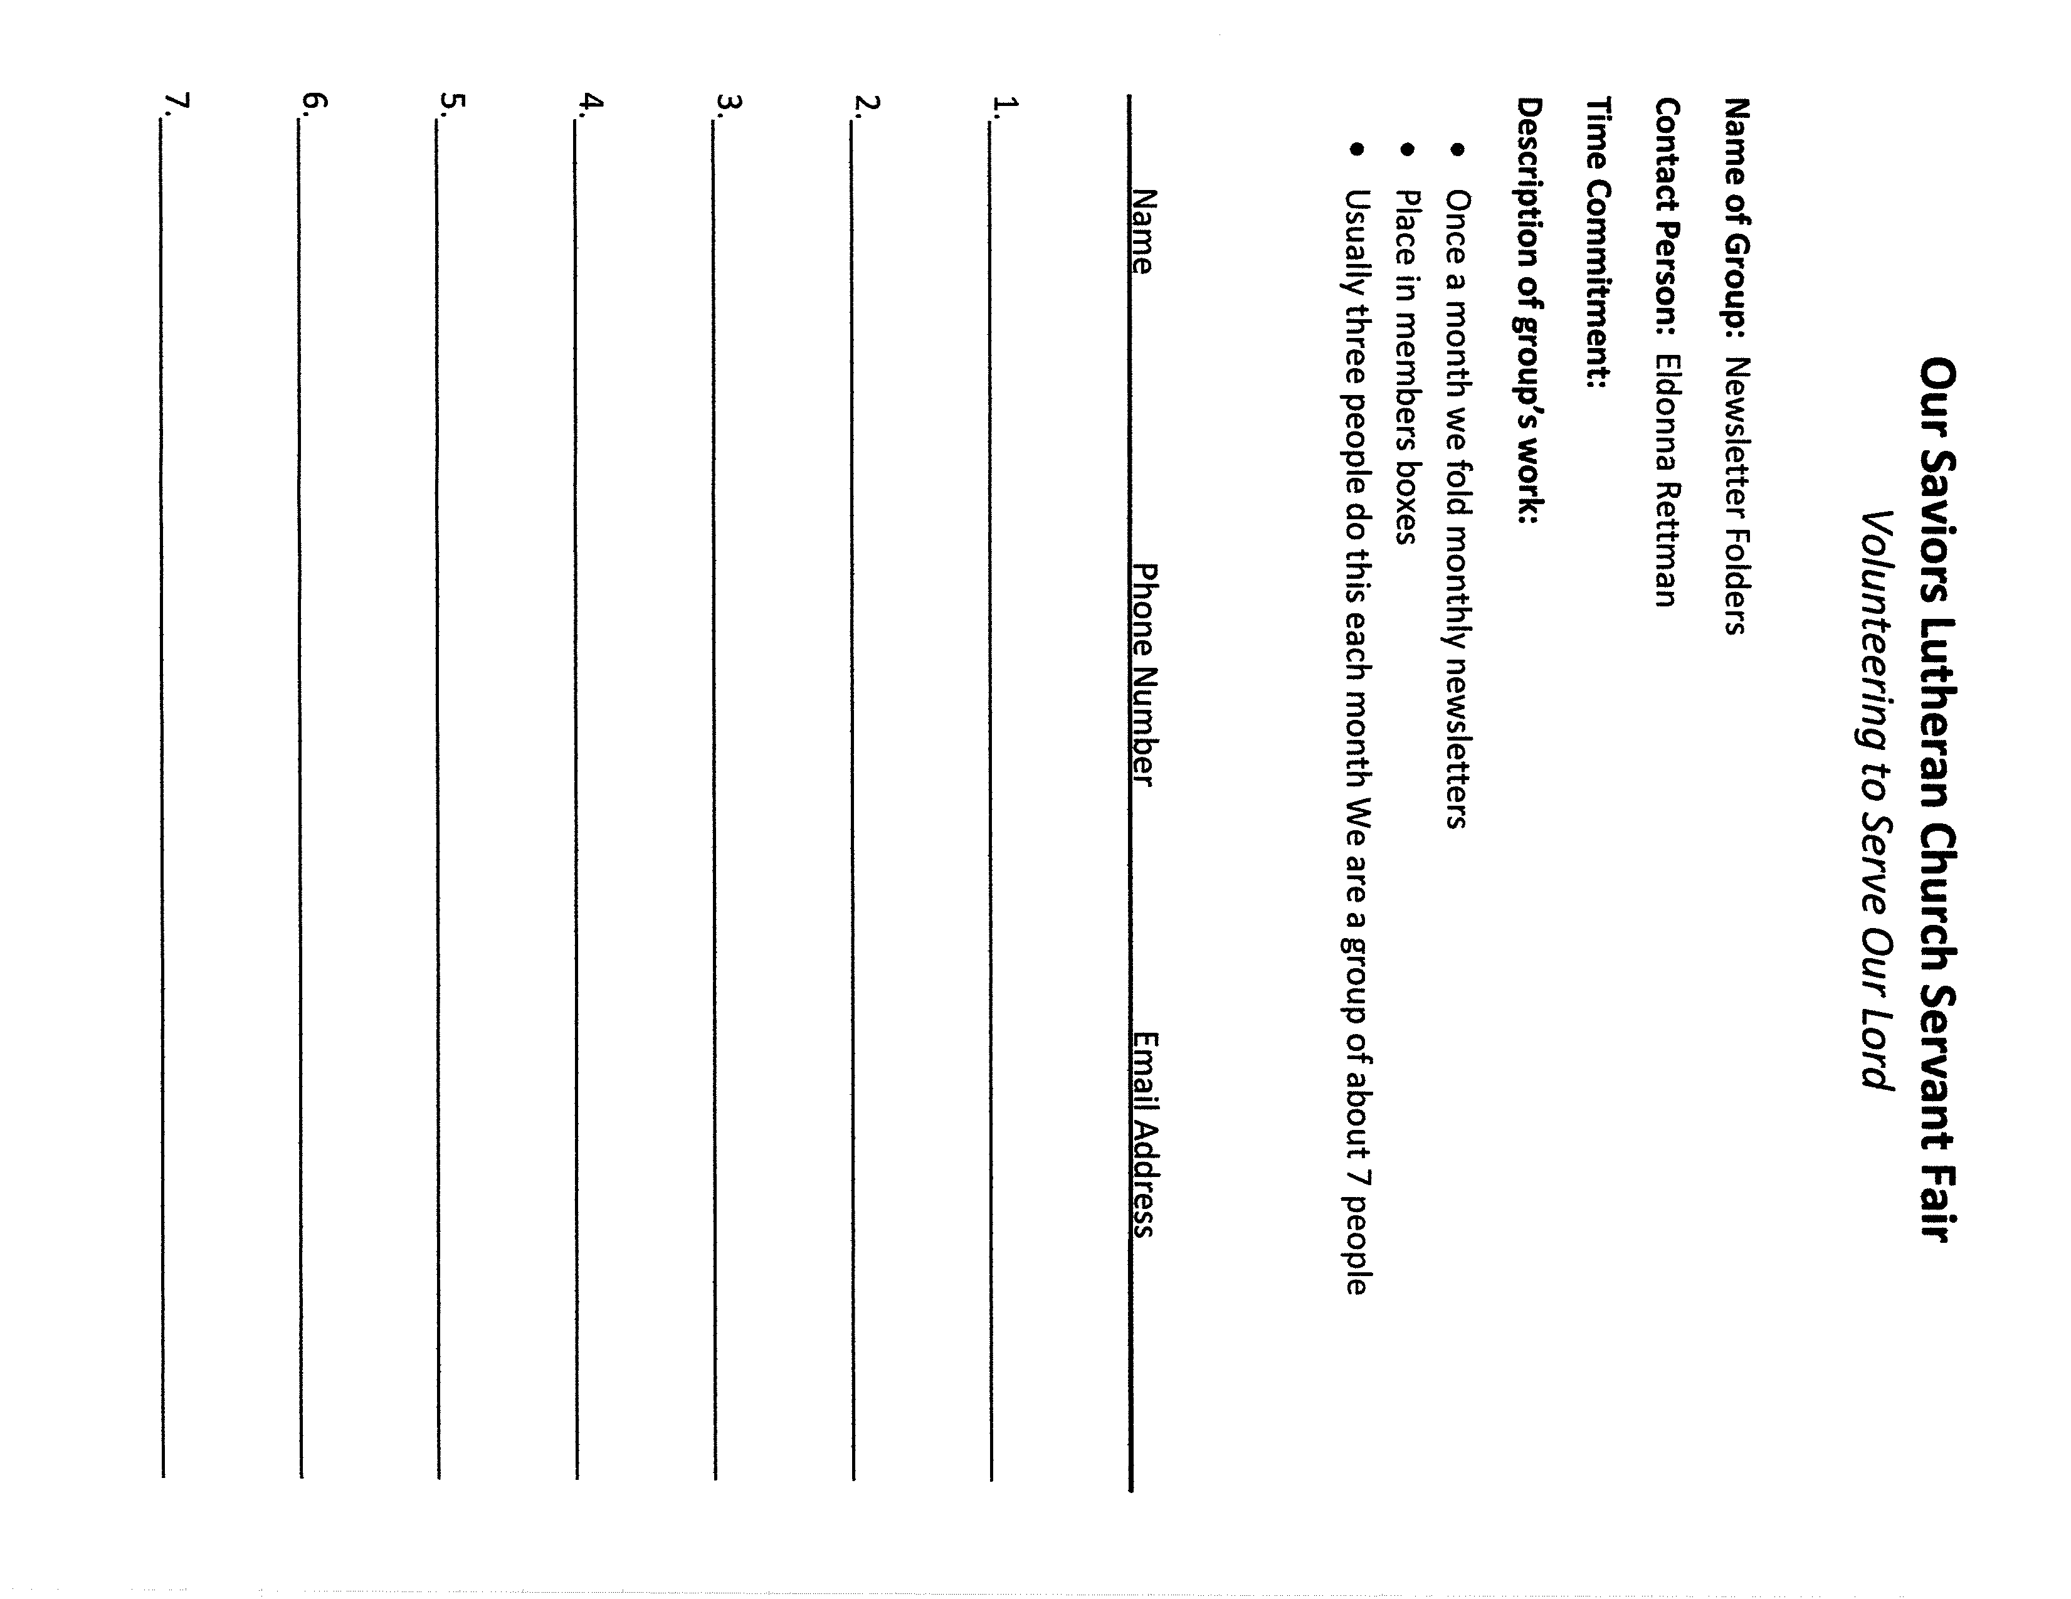
In January 2025, the Health Ministry hosted a Servant Fair to showcase the wide range of volunteer opportunities available at OSL. Each month, we’ll spotlight one or two of these opportunities to help you discover meaningful ways to connect—and stay connected—with your church family. Stay tuned and consider how you might get involved!
Servant Fair Opportunity of the Month
News from the Early Learning Center
The ELC is ready to have a fresh year. We are planning family engagements, staff training, and curriculum for our classrooms.



We are starting the year celebrating Lutheran School Week. The kids and staff look forward to celebrating each day. This year the theme is “Make a Joyful Noise”. We are ending the week with a glow party.

Our Valentine’s Family Engagement will be on Friday February 10th. Always a great connection to God Loves You with families.


Lori Holtberg
OSL Director


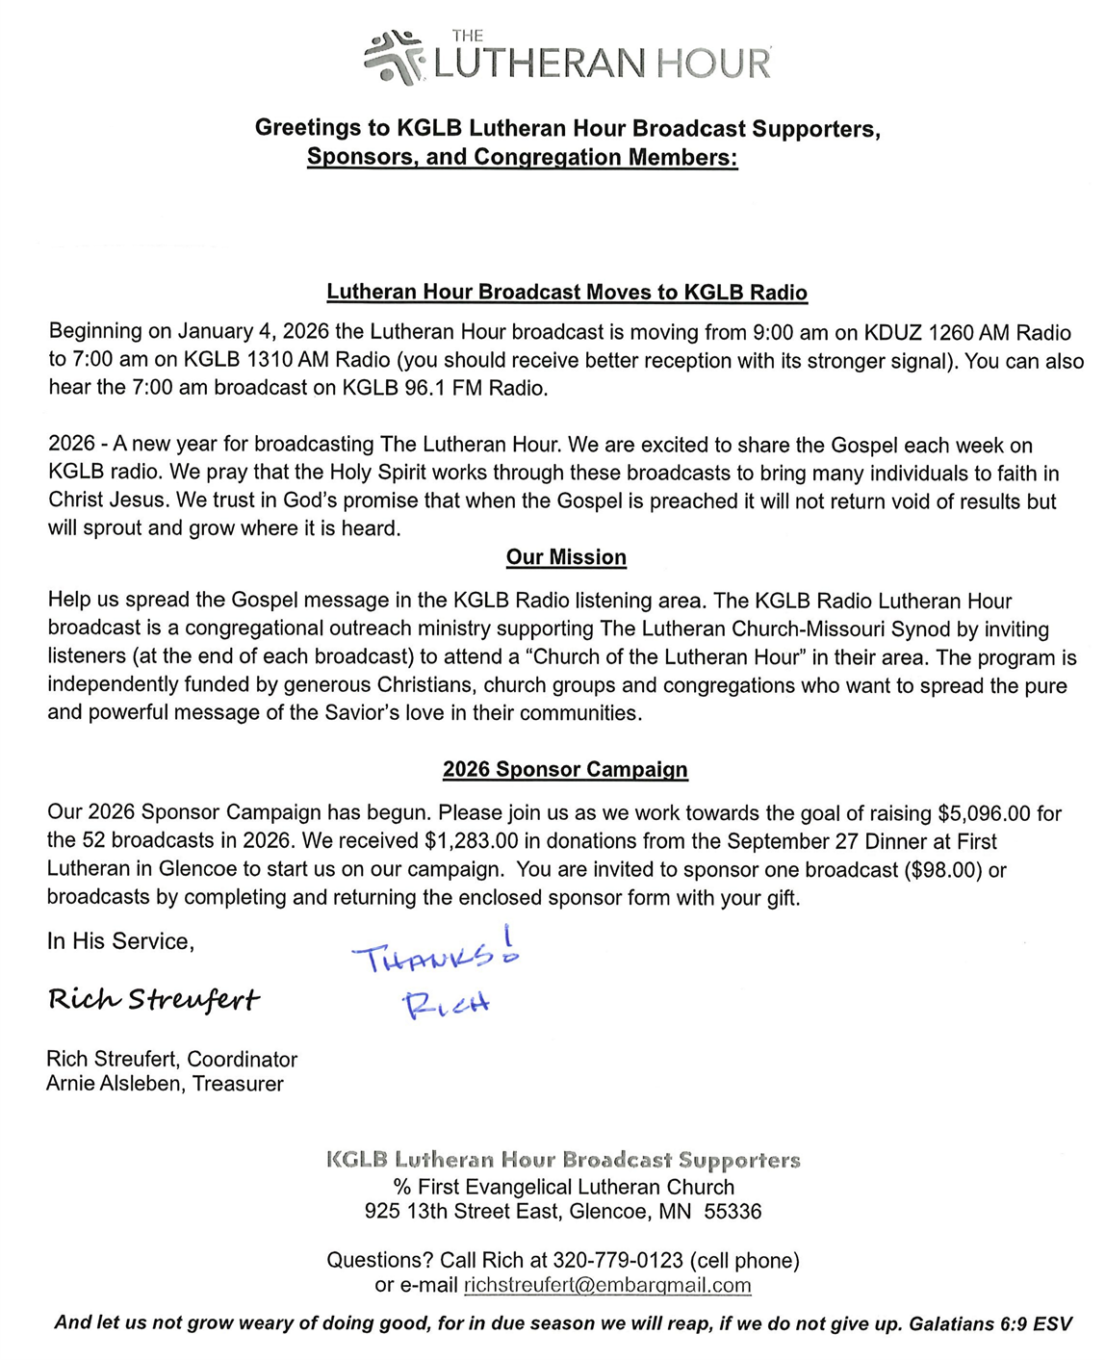
Upcoming Guild Events
Our Savior’s Lutheran Women’s Guild News

Remember all ladies of the congregation are invited to join us!

- All ladies of the congregation are invited to our February Guild meeting to be held on Tuesday, February 10th beginning with lunch at 11:30 a.m. Our program for this meeting will include a speaker from Common Cup who will explain the “Backpack Program” organized through Common Cup. After the meeting our volunteers will go to Common Cup to actually pack the bags for the current week’s distribution to the children in our school district. Please join us to learn about this community mission project and to help if you can!

- Guild work Group 1 will be sponsoring the Harmony River Birthday Party in February to celebrate all those residents with February birthdays.

- AbleLight (Bethesda) Thrift Store visit is scheduled for Thursday, February 12th. Contact Sharon Haberkamp if you would like to assist with duties at the Thrift Store.

- Quilters will be meeting on Monday, February 16th at 9:00 a.m. in the Commons to tie quilts for Orphan Grain Train and Dakota Boys and Girls Ranch. Newcomers are always welcome!

- Look for Guild Lenten soup suppers to be served in February and March.

- The Guild will be sponsoring Food Shelf Sunday on March 8th.

- Looking forward to March, the Guild will be meeting on Saturday, March 14th, at 9:00 a.m. beginning with coffee and treats. Pastor Gadbaw will be leading us in Bible Study. Please bring an item to fill our cart for the local food shelf. Note the change in date and time of the meeting. You are welcome to join us if you cannot make our regular monthly meetings!

The Lutheran Women’s Missionary League (LWML) is an official auxiliary of The Lutheran Church—Missouri Synod. Since 1942, the LWML has focused on affirming each woman’s relationship with Christ, encouraging and equipping women to live out their Christian lives in active mission ministries and to support global missions.

Mission Statement
As Lutheran Women in Mission, we joyfully proclaim Christ, support missions, and equip women to honor God by serving others.
Vision Statement
The LWML is the leading group for LCMS women where each woman is welcomed and encouraged to use her unique God-given gifts as she supports global missions and serves the Lord with gladness.

Our Savior’s Lutheran Women’s Guild News
Highlights of the January 13, 2026 Guild Meeting

The OSL LWML Women’s Guild met on Tuesday, January 13th at 11:30 a.m. in the Commons, beginning with lunch. Twenty-three people, including guests, attended.
- Vice President Jackie Morris welcomed attendees and guests.
- After the meal, Jackie led the group in a devotion about the mustard seed.
- Jackie introduced our mystery speaker, Jason Coyle, who gave a very interesting presentation regarding his personal life and his work in the church.
- For their January mission project, the Guild will be collecting new/gently used towels and small blankets for the local animal shelter.
- Our January Human Care project will be the assembly of coffee mug gifts after the meeting to be distributed to our homebound congregation members.
- Cheer Chair Vivian Gonzalez reported sending a total of 3 cards in December.
- Sharon Haberkamp reported that she traveled to AbleLight Thrift Store on Thursday, January 8, 2026. She also reported that 30 lbs. of food was taken to the Emergency Food Shelf in the month of December.
- Work Group 3 served the Advent Soup supper on Wednesday, December 10, 2025.
- Jeanette Bening reported that the quilters will be meeting on Monday, January 19, at 9:00 a.m. in the Commons. Eight quilts were tied in December.
- Distribution of the $2500.00 proceeds from the Cookie Walk were determined as follows: $500.00 to Seminarian Wesley Deiss; $500.00 to Dr. Semann and the New Freedom Store; $500.00 to Hutchinson Birthright; and $1,000.00 to LWML MN South District Mites for Mission Projects.
- The 2026 Guild Program booklet was distributed at the meeting.
- Next month’s meeting will be held on Tuesday, February 10th. A speaker from Common Cup will be available to explain their backpack program. After the meeting volunteers will be asked to go to Common Cup to pack food bags for the backpack program as our February Servant Event.


Lent & Easter Schedule
Ash Wednesday
February 18th
5:00 Soup Supper
6:30 p.m. Service with Communion

February 25th
“The Robe of Human Frame”
5:00 Soup Supper
6:30 p.m. Service

March 4th
“Done for Us”
5:00 Soup Supper
6:30 p.m. Service

March 11th
“For Us He Seeks”
5:00 Soup Supper
6:30 p.m. Service with Communion

March 18th
“Healing from Demons”
5:00 Soup Supper
6:30 p.m. Service

March 25th
“For Us Betrayed”
5:00 Soup Supper
6:30 p.m. Service with Communion

Maundy Thursday
April 2nd
“For Many Means for You”
6:30 p.m. Service with Communion

Good Friday
April 3rd
“His Dying Breath”
6:30 p.m. Service

Easter Sunrise
April 5th
6:30 a.m.
“For Us He Rose From Death Again”

Easter Divine
April 5th
“For Us He Lives on High to Reign”
9:00 a.m. Divine Servie with Communion



Have you designated your Thrivent Choice Dollars for 2025? They can be designated for the Early Learning Center, Our Savior's Lutheran Church (like the roof loan) or any qualified non-profit of your choice. It is easy to do: simply call 1-800-847-4836 and say, "Thrivent Choice." Have your ID number ready and some nice person will help you through the process. Don't let your Choice Dollars go unused! The deadline is March 31, 2026.

Sunday, February 1st is “Go Red” for Heart Health Sunday.
Please remember to wear your red to church and plan to have your picture taken after the service!
This and That
Sages Gathering XXXVI May 4 & 5, 2026
Country Inn And Suites, Mankato MN
Registration information will be coming mid-February.
No preconfirmation on Monday, February 16th.
FRIENDSHIP CLUB

The next social event of this group is scheduled for Friday, February 6th from 1:30-3:00 p.m. in the Commons here at OSL. All widows and widowers are welcome!

"Blessed be the God and Father of our Lord Jesus Christ, the source of all mercy and the God of all consolation. He comforts us in all our sorrows so that we can comfort others in their sorrows with the consolation we ourselves have received from God.” (II Corinthians 1:3-4)
Orphan Grain Train


Thank you to everyone who participated in the Orphan Grain Train Christmas Project!

The following items were collected from the tree in church: 32 ski caps, 10 headbands, 5 scarves (4 crocheted), 1 hat & scarf set, 7 hat & glove sets, 2 glove & earmuff sets, 3 summer caps, 2 women's hats, 25 hand knitted boys' & girls' hats, 25 hand knitted men's & women's hats, 26 hand knitted hats (various sizes), 2 pair girls' sandals, 1 pair girls' tennis shoes, 6 pair youth shoes (3 tennis, 3 sandals), 2 pair women's shoes, 3 pair men's tennis shoes, 2 pair men's camouflage shoes, 5 adult sandals, 4 pair toddler slippers, 3 pair girls' slippers, 4 pair children's slippers, 3 men's jackets, 26 men's fleece pants, 1 pair men's gloves, 2 pair women's gloves, 19 pair one size fits all gloves, 1 pair children's mittens, 25 fleece throws, 62 pair men's socks, 1 pair women's soft slipper socks, 2 pair women's Fuzzy Heart socks, 4 pair ladies' lounge socks, 18 pair women's socks, 44 pair girls' youth socks, 65 pair boy's & girls' toddler ankle socks, 10 pair boys' low cut socks, 15 pair girls' low cut socks, 10 pair youth socks, 5 girls' t-shirts, 6 men's long leg boxer briefs, 7 women's briefs, 2 toddler girls' briefs, 4 toddler boxer briefs, 6 potty trainer girls' briefs, 77 girls' cotton briefs, 14 pair Fashion Tights, 8 pair Fashion - Pointelle, 4 women's stretch tops, 2 girls' shorts. We also sent a check for $75 to help defray shipping expenses.

Thank you to Sue Forcier who prepared the boxes for packing. Thanks to Dave Radunz for helping close and seal all the packed boxes. Thank you to Shirlee Landskroener for taking all the packed boxes to Mayer, MN to the person connected with Orphan Grain Train.

Orphan Grain Train, an LCMS Recognized Service Organization based in Norfolk, NE, reaches people all over the world with Christ's mercy. Many people will be blessed because of your loving hearts and generous spirits! Praise God for your giving hearts! God is so good!

Celebrating this Month

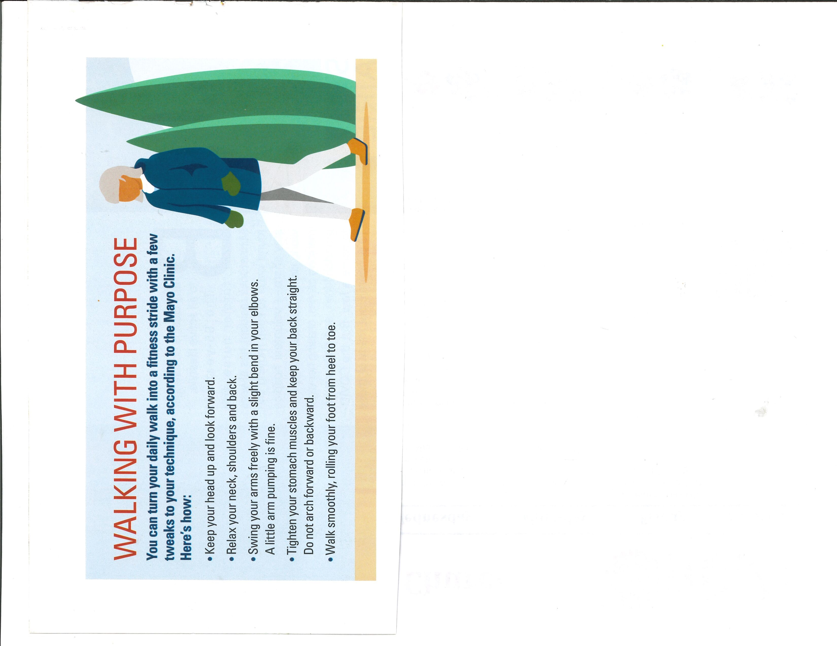
2/1 Joyce Cruser
2/2 Marlin Schauer
2/3 Kylie Knodel
2/4 Jeremy Jorgensen
2/6 Brady Zackrison
2/8 Keith Messner
2/9 Philip Forcier
2/10 Alex Messner
2/11 Jerome Stoll
2/13 Harriet Schmidt
2/14 Ava Paulson
2/15 Beverly Hanson
2/15 Scott Schindler
2/16 Matthew Schumann
2/17 Jonathan Crosby
2/17 Karen Gensmer
2/18 Khiana Knuth
2/22 Orlin Ortloff
2/23 Nigel Paulson
2/27 Chloe Paulson



2/9 Chuck and Linda Esser 35 Years



Ministry Staff
Rev. Daniel Gadbaw Pastor
Shirlee Landskroener Music Director
Karen Ostlund Sunday School
Sherry Drahos Administrative Assistant

2026 Church Officers
Chairman Marshall Kranz
Vice Chairman Kevin Mathews
Secretary Wanda Rannow
Treasurer Dale Ortloff

Elders
Mark Bening, Chairman
Paul Barchenger
Jason Coyle
John Gillard
Jim Lauer
Jeff Siedschlag

Trustees
Mike Metzger
Chuck Esser
Adam Field

Custodians
Jeff Radunz
David Radunz

Early Learning Center Staff
Lori Holtberg Early Learning Director
Carrie Farley Healthcare Consultant
Shirley Alsleben Cook
Cora Bjorngjeld Childcare Team
Rachel Carlson Childcare Team
Laila Dubay Childcare Team
Lucy Dubay Childcare Team
Kaloni Erickson Childcare Team
Morgan Glieden Childcare Team
Alysha Hatton Childcare Team
Miranda Heine Childcare Team
Katarina Larson-Schmidt Childcare Team
Shelby Norgaard Childcare Team
Tracy Polzin Childcare Team
Kadi Powell Childcare Team
Ginny Rogers Childcare Team
Paige Slinden Childcare Team
Jovilynn Stoll Childcare Team
Ana Sullivan Childcare Team
Kathryn Vesely Childcare Team
Courtney Williams Childcare Team

Early Learning Center Committee
Dean Brehmer Chairman
Gaylen Timm Finances
Ashley Buresh .Secretary
Rev. Daniel Gadbaw Pastor
Lori Holtberg Director
Linda Esser Representative
Our Savior’s Lutheran Church & ELC
800 Bluff Street, Hutchinson, MN 55350
320-587-3318
Website: www.oslhutch.com



